Application for Specialised School Transport Assistance (SESTA)
Before submitting this application, please read the following information about eligibility and the type of assistance that is available
What is SESTA?

SESTA is assistance from the Ministry of Education (“the Ministry”) so that children and young people with safety and/or mobility needs can attend their closest school.

While responsibility for transporting students to and from school rests with caregivers, the Ministry may provide assistance subject to the SESTA criteria being met. For more details, please visit http://www.education.govt.nz/sesta/

Who is eligible?

SESTA is for students aged between 5 and 21 years who have safety and/or mobility needs that prevent them from travelling independently to or from the closest state school, state integrated school or other educational setting that the student can enrol at.

- Safety needs may be indicated where a significant risk of harm or danger to the student, or to others, exists during the journey to and from school. This may be due to challenges such as epilepsy, communication and social skills, understanding, self-management and decision making.
- Mobility needs are indicated where the physical or health related needs of the student prevent independent travel to and from school or their accessing public transport or a school bus. This may be due to challenges such as reduced mobility, fatigue, medical conditions or limited motor skills.

SESTA is to the closest state school (or state-integrated school, or educational setting) that the student can enrol at, unless another school is deemed the “closest” where:

- A Regional Director of Education determines that because of the student’s specific needs they have to enrol at another school; or
- The student is attending a specialist school under an agreement under section 37 of the Education and Training Act 2020; or
- The student is subject to a directed enrolment under section 14 of the Education and Training Act 2020.

The fact that a school may be the closest, or deemed the closest does not in itself mean that SESTA in the form of a place in a vehicle is guaranteed. When deciding whether a place in a vehicle will be provided, the Ministry will consider:

- The safety of the student, other students and driver on the service;
- The length of time in a SESTA vehicle. Journey times (one way) should preferably be no longer than 40 minutes and must not exceed an hour;
- The cost and availability of the service.

Type of assistance you may receive

SESTA may be a conveyance allowance payment to help you with the cost of transport, or may be a place in a vehicle.

In cases where a student is otherwise eligible for SESTA but is not attending the closest school they can enrol at, SESTA assistance will only be in the form of a conveyance allowance to the closest school. A place in a vehicle will not be available.

Where the availability of SESTA is likely to affect school enrolment decisions by caregivers, eligibility for SESTA should be determined before confirming enrolment.
Caregivers should discuss enrolment options with their school and the local Learning Support team at the closest Ministry Regional office: https://www.education.govt.nz/ learning-support-services/ or call 0800 622 222 or email learning.support@education.govt.nz

Student-centric Service

Ministry decisions are based on the needs of the student. The Ministry is not able to take into account the caregiver’s financial position, hours of work or other unique circumstances.

Safety of the service
Safety is very important when transporting students to and from school. A Safe Travel Plan is available on the parent’s web page (see page 5 of this application) and used to share key information in order to support the safe travel of the student. Assistance with the provision of specialist equipment can also support safe travel.

The Ministry is responsible for monitoring contracts with transport providers to make sure safety requirements are met. Caregivers are responsible for letting the Ministry and transport operators know about any changes that may impact on the safety of the student or any other person.

When should this form be completed?
This form is for one student only. Please fill out additional forms for each student requiring SESTA.

This form needs to be completed as early as possible for new applications and whenever there is:

- A change or addition of address; and/or
- A change of school, including a move to or from a satellite class; and/or
- A change in circumstances (such as changes in the student’s health, mobility or safety).

All applications are reviewed for ongoing eligibility.

Applications for Term 1 2019 need to be received at the Ministry’s School Transport National Office team by 3 December 2018

Which sections do I need to fill out?
This form has the following sections:

- Section A – to be completed by the caregiver together with the enrolling school
- Section B – to be completed by the Ministry of Education Regional Office.

Completed forms are then sent by the Ministry Regional office to the Ministry’s School Transport Team in Wellington.

The School Transport Team aims to process the completed application within 10 working days of receiving it from the regional office and makes the final decision on SESTA eligibility and form of SESTA provided.

Please note that applications involving a place on a vehicle service should be submitted as early as possible. If a Transport provider needs to purchase a vehicle or hire a driver who requires to be police-cleared, this can take several weeks. The Ministry requests that applications for new or amended services are submitted at least one full school term before the service is required.

Privacy
The personal information on this form is being collected for the purposes of assessing eligibility for SESTA and for reporting and evaluation purposes. The information collected by the Ministry may be used or disclosed by the Ministry only for these purposes.
The information will be used and held by the Ministry under the Privacy Act 1993 (and, where applicable, the Health Information Privacy Code 1994), and you have the right to see the information and ask us to correct it.
Please note that all SESTA vehicles are fitted with internal security cameras. The camera footage is only able to be reviewed by Police, and we require our operators to keep at least the last 168 hours of footage available.
Contact:
For information regarding applications that have been submitted to the School Transport team, please contact us on 0800 BUS 2 SCHOOL (0800 287 272) or email school.transport@education.govt.nz
Section A: to be completed by the caregiver with the enrolling school
This form is for one student only

Please complete all boxes. Clear printing will help with processing the application.
Application type
Has the student previously received SESTA? | yes no
If yes, please provide reason for this application | A change or addition of address  A change of school  A change in the student’s safety and/or mobility needs  Change of service required
Type of assistance requested | Place in a:  car or van  total mobility vehicle (wheelchair accessible)  (If a wheelchair is to be transported, please provide specifications (noting whether foldable or powered) and weight):  _____________________________________________________________  _____________________________________________________________  Conveyance allowance – Conveyance allowance is calculated at $0.27 / km to a maximum of $20.00 per day. It is paid in arrears directly into the caregiver’s bank account monthly depending on the return of an attendance report from the school.  Please attach a copy of a pre-printed or bank-verified deposit slip to all applications for a conveyance allowance. Hand-written account numbers and ATM receipts cannot be accepted.
Is the caregiver currently receiving a conveyance allowance from the Ministry for this student? | yes no

Student Details
First name(s)
Surname
(R1) Primary Residential address | (Post code)
(R2) Second residential or respite address | (Post code)
(R3) Third residential or respite address | (Post code)
Date of birth, enrolled year of student, NSN and ORS | DOB: Enrolled school year level:  NSN Number: ORS Verified?: yes no  ORS Number: ________________
Gender | male female gender diverse
Can the student be left home alone? | yes no N/A – conveyance allowance application only  Further detail: ____________________________________________  Caregiver initial:  Note: Students under 14 years old cannot legally be left at home unsupervised
Student Needs  Safety Needs:  (Please provide a detailed functional description of what the student can and cannot do without support to describe any significant risk of harm or danger to the student, or to others that would exist during the journey to and from school if SESTA was not provided. This may be due to challenges such as epilepsy, communication and social skills, understanding, self-management and decision making.) | _____________________________________________________  _____________________________________________________  _____________________________________________________  _____________________________________________________  _____________________________________________________  _____________________________________________________  _____________________________________________________  _____________________________________________________  _____________________________________________________
Mobility needs:  (Please provide a detailed functional description of what the student can and cannot do without support to explain why the physical or health related needs of the student prevent independent travel to and from school or their accessing public transport or a school bus. This may be due to challenges such as reduced mobility, fatigue, medical conditions or limited motor skills.) | _____________________________________________________  _____________________________________________________  _____________________________________________________  _____________________________________________________  _____________________________________________________  _____________________________________________________  _____________________________________________________  _____________________________________________________  _____________________________________________________
Current transport method:  (Please provide a detailed functional description of how the student is currently transported unless this is fully covered above. Replicating the current method of transport can reduce anxiety and risk. Provide detail of such things as whether the student always sits in a certain place in your vehicle, always has the radio off or window open slightly etc.)  Is specialist equipment (e.g. a safety harness) required? | _____________________________________________________  _____________________________________________________  _____________________________________________________  _____________________________________________________  _____________________________________________________  _____________________________________________________  _____________________________________________________  _____________________________________________________  yes no N/A – conveyance allowance application only  (If “Yes”, an application for specialist equipment should be downloaded from the parents’ website at https://parents.education.govt.nz/learning-support/learning-support-needs/transport-assistance/. The completed specialist equipment form should accompany this application.)
Safe Travel Plan  - Do the student’s behaviours pose a risk to themselves or others while on a vehicle service?  - Does the student have a medical, behavioural or physical condition that may require assistance while on a vehicle service? (eg epilepsy) | yes no N/A – conveyance allowance application only  yes no N/A – conveyance allowance application only  Note: If the answer to either question is “yes” – a Safe Travel Plan must be completed and attached to this application. Failure to provide the plan may lead to delays in processing this application
Can the student share a vehicle with others? | yes no N/A – conveyance allowance application only
Can the student travel on a school bus, now, or in the future? | yes no N/A – conveyance allowance application only
Caregiver Details
Title | Mr Mrs Ms Miss Dr Other:
First name(s) |  | Surname
Postal address (please provide postcode) | (Post code)
Contact phone numbers (please provide area code) | Mobile ( ) Home ( )  Work ( )
Email

Emergency contact (Must be a person other than the caregiver)
Title | Mr Mrs Ms Miss Dr Other:
First name(s) |  | Surname
Contact phone numbers (please provide area code) | Mobile ( ) Home ( )  Work ( )
Enrolling/proposed school details
(S1) Name and address of school or satellite to be attended. If the enrolling school is different to S1, note both schools and clearly indicate which is which.
What is the distance by road from the student’s main address? | ___________________ km
Is this a health school?  Is this a specialist school?  Is the student enrolled at the school under a Specialist Education Agreement? | yes no  yes no  yes no
Is this school or satellite the closest age/gender appropriate school to the student’s primary residence?  (Please note: SESTA assistance is normally only available to the closest school as per page 1, although for the purposes of SESTA, a school is deemed “closest” if a student is attending under a directed enrolment.) | yes  no  N/A (attending a specialist school under an agreement under Section 37 of the Education and Training Act 2020 or a directed enrolment under Section 14 of the Education and Training Act 2020)
If no, why does the student not attend their closest school?  Please tick as many boxes as appropriate and provide information to explain your reasons. | Student has been excluded from the closest school(s)  Parental choice  Other (please explain):  ________________________________________________________________________________________________________________________________________________________________________________________________________________________
(S2) Will this student need to travel from home to attend another satellite/off site location? | yes no
What is the satellite/off site name and address?

What is the distance by road from the student’s main address?

Weekly Itinerary (Not required if application is for conveyance allowance for the full week)
Travel is generally to and from school but may include routine travel to different home addresses, respite or after-school care. Travel to respite care can only be provided in situations approved by the Ministry. Please enter residences, schools and special facilities by the code assigned to them in the previous sections of this form, e.g. residences as R1, R2; schools as S1, S2. Please also enter departure and arrival locations and estimated arrival/pick up times on applicable days in the table below.

Example of Weekly Itinerary:
Trip | From | To | School start/finish time
Monday am | R2 | S1 | 8.45 am
Monday pm | S1 | R1 | 3.00 pm
In this example, the student was picked up from their respite address (R2) by taxi/van/bus to arrive at their main school (S1) at 9.15am. They were picked up from the school at 3.30 pm by vehicle, and returned to their main residence (R1).
Trip |  | From | To | School start/finish time | Conveyance allowance only Required | Vehicle Required
Monday | am
 | pm
Tuesday | am
 | pm
Wednesday | am
 | pm
Thursday | am
 | pm
Friday | am
 | pm
Is there a plan to transition the student to another school? If yes – please state which school and when. | __________________________________________________________________________________________
Date the service is required to start (please note that arranging new services and drivers may take several weeks) |  | DD MM YY
Caregiver checklist and declaration
- I have discussed this application with the enrolling school and have read and understood the criteria and conditions to receive support set out in this application
- I understand that any second residential address or respite address is a person or organisation acting in my place as caregiver
- I have provided appropriate bank account details for my conveyance allowance application (if relevant)
- A Safe Travel Plan is completed (if relevant)
- I will abide by the conditions of carriage provided by the transport operator if offered a place in a SESTA vehicle.
- I understand that SESTA vehicles have fitted security cameras
- The information I have provided on this form is true and correct.

Caregiver name (please print) Caregiver Signature and date

School checklist and declaration
- The caregiver(s) have discussed this application with me
- I understand the criteria for SESTA set out in this application and described at https://www.education.govt.nz/sesta/
- The information I have provided on this form is true and correct

Additional comments if required:
________________________________________________________________________________________________________________________________________________________________________________________________________________________________________________________________________________

________________________________ _______________________
Signature of principal (or other authorised person) Please print name

Date: _____/_____/_______
Telephone: |  | Email:

Please send completed form to your local Ministry of Education Learning Support Office for Section B to be completed.

A list of offices is available at: https://education.govt.nz/ministry-of-education/regional-ministry-contacts/learning-support-services/

Section B Part 1: to be completed by Ministry of Education Learning Support Office
Student safety and mobility needs
This section should ideally be completed by a person who knows this student such as a lead worker. It should be signed off by the Service Manager or Manager Learning Support. Where the student is not known to the Ministry, they should contact a person who does know the student, for example a school principal, staff member, SENCO or a Resource Teacher: Learning and Behaviour (RTLB) before completing Section B

Does the student meet the safety and/or mobility criteria to be eligible for SESTA?  (Note: Applications cannot be supported until it is possible to determine whether the safety and/or mobility eligibility criteria for SESTA are met.) | Safety? yes no  Further details:  Mobility? yes no  Further details:
Is a Safe Travel Plan attached?  A plan is required if the student’s:  - behaviours pose a risk to themselves or others while on a vehicle service, or  - medical, behavioural or physical condition may require intervention while on a vehicle service.  (Note: if a Safe Travel Plan is required and not supplied, please return to the school and caregiver for completion) | yes no N/A – conveyance allowance application only

Closest school test

Students with mobility and/or safety needs will be eligible for SESTA if they are attending the closest state school (or state-integrated school, or educational setting) that the student can enrol at.

For the purposes of the SESTA application a school is treated by the School Transport Team as the “closest” at which the student can enrol if:

- It is the geographically closest state school (or state-integrated school, or educational setting); or
- A Regional Director of Education determines that because of the student's specific needs they have to enrol at another school; or
- The student is attending a specialist school under a Specialist Education Agreement under section 37 of the Education and Training Act; or
- The student is subject to a directed enrolment under section 14 of the Education and Training Act 2020.

In cases where a student who is otherwise eligible for SESTA is not attending the closest school they can enrol at, SESTA assistance will only be in the form of a conveyance allowance to the closest school. A place in a vehicle will not be available.
Is the enrolling school the geographically closest (to the student’s primary residence) state school, state integrated school or other educational setting the student can enrol at? | yes no  (If “yes”, please go to “Time in Vehicle/Cost Criteria below)
If not the closest, is the student enrolled at a specialist school under a Specialist Education Agreement (previously known as section 9 agreement)? | yes no  If “yes”, please go to “Time in Vehicle/Cost Criteria below)
If the enrolled school is not the geographically closest, what school is? | Name/address of geographically closest age and gender appropriate school:____________________________________________  __________________________________________________  Distance from student’s primary residence: __________ km
Is there an exceptional reason why the student cannot attend the geographically closest state, state integrated or other educational setting the student can enrol at? | yes - please complete the rest of the form, with Regional Director of Education signoff required in part B.2  no - a place in a vehicle cannot be provided and the caregiver will be advised that SESTA if approved will be in the form of a conveyance allowance to the closest school.

Time in vehicle/cost criteria
When considering SESTA applications to the closest school (actual or deemed by way of Regional Director’s agreement under part B.2 of this form), the School Transport team will consider:

- If any vehicle service can be provided safely
- Time in vehicle: journeys one way should not exceed 40 minutes and must not exceed an hour in duration
- Cost limits: journeys exceeding $100 day will generally not be approved unless exceptional circumstances apply, and will usually in these cases be time limited and subject to review.

What is the distance by road to the enrolling school or satellite from the student’s primary residence? Note: Google maps can be used to provide an indication | ________ km
What is the estimated time in a vehicle one way? Note that Google maps will provide an indication only: actual journey times will likely be longer as SESTA services stop to pick up other students and may be limited to 80 km/hr on the open road. | Approximately _________ minutes
Please contact School Transport if an early indication of cost and time in a vehicle is required to help inform an enrolment decision. The School Transport Team will obtain details from the Transport Service Provider and advise if a vehicle service can likely be provided within cost and time in vehicle limits. Please note that if a service cannot be provided, and the student is otherwise eligible, SESTA in the form of a conveyance allowance to the closest school the student can enrol at (actual or deemed) will be provided.

Lead Worker Affirmation (to be completed for all applications)
- I am satisfied that the form is fully completed, with proof of bank details if relevant.
I am satisfied that this student:
  - Meets SESTA age criteria (aged 5-21 years)
  - Meets Safety and Mobility Criteria, and, if relevant, a Safe Travel Plan is attached
  - Is attending the closest state school (or state-integrated school, or educational setting) that the student can enrol at (closest school includes specialist school attendance under section 37 or directed enrolment under section 14)
  - Is NOT attending the closest state school (or state-integrated school, or educational setting) that the student can enrol at

Lead Worker (Please print name) Signature and date

For Service Manager Completion

- The student is attending their closest school and this application is supported – or –
- The student is NOT attending their closest school and part B.2 needs completion – or –
- This application is NOT supported for the following reasons:
___________________________________________________________________________________________
___________________________________________________________________________________________

Service Manager (Please print name) Signature and date
If the student is NOT attending the closest school, please complete Part B.2 otherwise the form should now be forwarded to School Transport.

Section B.2: to be completed by Manager Learning Support and approved by the Regional Director of Education
This section is used if the Manager Learning Support agrees with SESTA to a school that is not the closest age and gender appropriate school the student can enrol at, the student is not attending a specialist school under a section 37 agreement or directed enrolment under section 14, and there is an exceptional reason why the student should enrol at this school which relates to the student’s specific needs. The following process is used to determine the “closest” school the student can enrol at for the purposes of the SESTA application.

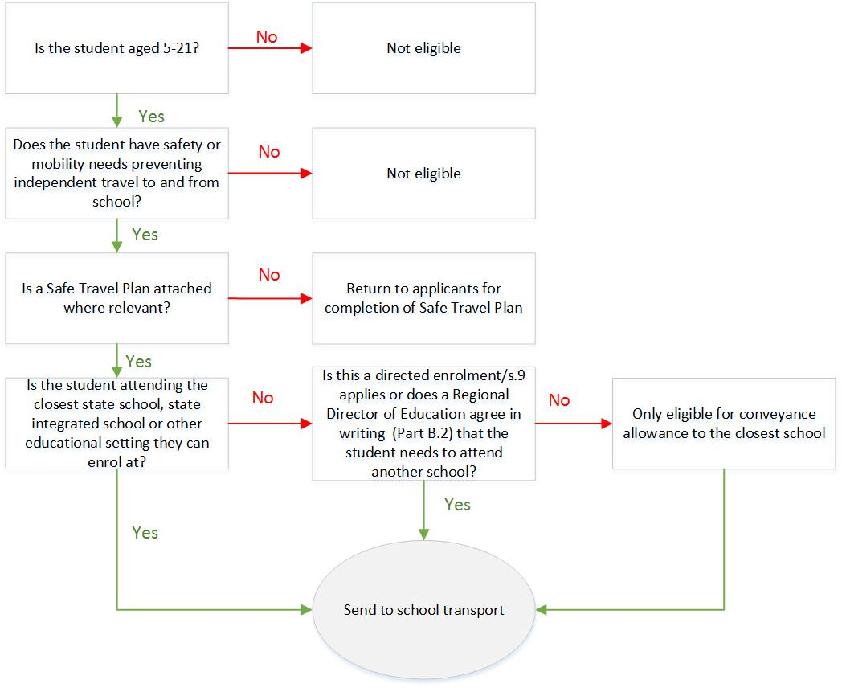

Can this student attend their closest age and gender appropriate school? yes no

Comments: please explain why the student cannot attend their closest school and if these barriers can be addressed locally:
__________________________________________________________________________________________
__________________________________________________________________________________________
__________________________________________________________________________________________

If a temporary arrangement or transition, when will this be reviewed?
DD MM YY

Please note that once this application is approved, the School Transport Team then applies the safety, time in vehicle and cost criteria in determining if the form of assistance provided is a conveyance allowance to the identified school or a place in a vehicle. Care needs to be taken that caregivers are not led to believe that the regional approval process will guarantee a place in a vehicle.

_____________________________________ __________________________________
Manager Learning Support (Please print name) Signature and date

For Regional Director of Education completion

This recommendation to identify _____________________________________ school as the “closest” for the purpose of this SESTA application is:
- Supported
- Not supported (note that the application should be referred back to Learning Support staff to engage with the caregivers on other options if required)
Comments (if applicable):
________________________________________________________________________________________________________________________________________________________________________________________________________________________________________________________________________________________________________________________________________
Regional Director of Education (Please print name) Signature and date
Please send completed form to school.transport@education.govt.nz
For queries please call 0800 287 272 (0800 BUS 2 SCHOOL)

